**ACKNOWLEDGEMENT**

If words are considered as a symbol of approval and token of appreciation then let the words play the heralding role expressing my gratitude.

The satisfaction that accompanies that the successful completion of any task would be incomplete without the mention of people whose ceaseless co-operation made it possible, whose constant guidance and encouragement crown all efforts with success. We are grateful to our project guide Mr. Nainesh Gathiyavala for the guidance, inspiration and constructive suggestion that helpful us in the preparation of this project. We also thank our colleagues who have helped in successful completion of the project.

Chopda Pratiksha

1. **Introduction**
   1. **Project description:**

“Events can be defined as” occurrences planned to communicate particular information to end audience”- Philip Kotler.

Simply telling Events are occasions, moments and happenings that just happen or are made to happen. Marriage, Pooja, Bartabanda, Dances, Jatras, Deusi-Bhailo, Concerts, Meetings, Exhibitions these all are examples of events.

And if we plan, bring the concept, search for sponsorships, decide the venue and make the event happen then it is called event management. For example to make a concert happen we have to first think of it and lastly, we make it happen. The process in between is event management.

* 1. **Project Profile:**

|  |  |
| --- | --- |
| **Project Title:** | Event Management System |
| **Definition:** | Event Management System are web-based application program. Users are choose place to organize events. |
| **Developed For:** | SDJ International College, Vesu, Surat |
| **Project Guide:** | Prof. Nainesh Gathiyavala |
| **Front End:** | Visual Studio code |
| **Scripting Language:** | PHP, MySQL |
| **Back End:** | XAMPP Server |
| **Operating System:** | Microsoft Windows 10/11 |
| **Tools used for ERD & DFD:** | Microsoft Word |
| **Submitted By:** | Chopda Pratiksha Bharatbhai |

1. **Environment Description**

**2.1 Hardware and Software Requirements**:

* **Hardware Requirements:**

|  |  |  |
| --- | --- | --- |
| Processor | : | Intel(R) Pentium i3 CPU @ 2.30GHz |
| Memory | : | 4 GB |
| Hard Disk | : | 128GB or Higher |

* **Software Requirements:**

|  |  |  |
| --- | --- | --- |
| Operating System | : | Microsoft Windows 7/10 |
| Front End | : | HTML, CSS, Bootstrap |
| Backend | : | PHP, MySQL |
| Input Device | : | Keyboard, Mouse |
| Output Device | : | Monitor |
| Browser | : | All Browser Supported |

**2.2 Technologies Used:**

* + - **Server-side Technology:**
      * PHP
      * MySQL
    - **Front-side Technology:**
      * HTML
      * Bootstrap
      * CSS
      * JavaScript
    - **Other Technology:**
      * Visual Studio Code
      * Window 10
      * Chrome
      * PHP MyAdmin

**3. System Analysis and Planning**

**3.1 Existing System and its Drawbacks:**

Planning an event has its fair share of struggles. No matter what the size of your event, any big or small occasion planning can face a lot of problems. There are many things that need to be controlled and monitored to avoid any difficulties. Pulling off a successful event may seem easy at first but the number of glitches you might face for it can be huge. Many challenges come in your way that can lead to serving consequences if not dealt with in the right time range when you are planning an event.

The customer service is now the most essential part of all service related companies or institutions. They have to give supports to save their business. However, in the high-priced world, it is now becoming more expensive for companies.

In some cases like online banking, access to personal data is only possible by secure identity check. This might require telephone contact.

Having a competent team can either make or break your entire event management business. Event management is all about teamwork so if you have unprofessional people on board then this can be a huge problem. People who are untrained in this field can cause you more amounts of trouble, which can make your work much tough.

**3.2** **Feasibility Study:**

The data collected during this survey showed that there is a high percentage of population who uses smartphones which support many mobile based on application. Also there is a high percentage of chat application users in the country and many uses these applications as a means of communication in a family even though some of these applications have security issues. Hence, these data indicate that there is a very good market share for a new chat application with good security feature and developed in our own country. For additional support to prove the feasibility of development of chat application of the country. Which indicates a high percentage of the population would use the chat application developed in our own country.

* + - **Technical Feasibility:**

The technical Feasibility work for the project is done with the present equipment, manual procedures, and existing software technology & available technology hardware. The necessary technology, front-end, backend database technology, and other tools namely reporting tool, installation tools, etc., (as mentioned in the project profile) for developing the system, are already available within the organization.

* + - **Economical Feasibility:**

Economic feasibility looks at the financial aspects of the project. Economic feasibility concerns with the returns from the investment in a project. It determines whether it is worthwhile to invest the money in the proposed system. It is not worth while spending a lot of money on a project for no returns. To carry out an economic feasibility for a system, it is necessary to place actual money value against any purchases or activities needed to implement the project.

* + - **Operational Feasibility:**

This phase is system operations performed by proposed system in this phase here testing is the important point is user will be operating the system. System will work under any condition .System will allow entering & retrieving of Data only to authorized user to operate the system. It will work any full efficiency & accuracy as used to work with particular computer. There is sufficient support to the project from the management and from the intended users of the system.

**3.3 Requirement Gathering and Analysis:**

Requirement Gathering or commonly known as the Discovery Phase is basically a process in which we understand and identify a business’s project technical requirements and proceed with a well-defined plan.

Although the discovery phase is an essential phase in any critical project plan, it is quite often overlooked with the absence of sufficient ground work.

Some of the project managers/consultants might argue that if a client’s requirements are accurately identified in the early stages, then completing a full phase of requirements gathering is simply not needed. One can actually not stress enough on the importance of discovery phase.

The first concern is to ensure that the software is compatible to the various platforms and devices of your customers. The solution must run smoothly on all devices, catering to all operating systems. As a business owner, you cannot control what devices or on which OS your customer is using. It is better to choose a chat support solution that runs on all and if not the most popular platforms like different web browsers, android and iOS apps.

The next live chat requirement for your business should be automation. If you are investing in CRM integration, then might as well deploy a chat box for efficiency. This is highly recommended for e-commerce and finance-based businesses. Based on customer’s journey with the brand, the AI will make relevant recommendations to the customer.

At times, customers do not identify their problems correctly and end up in the wrong department. When this happens over chat, the agent on-task should be able to transfer the customer to the right department, without much hassle. The chat transfer feature will smoothen this process, while reserving the context for the next agent. Due to this, the customer does not have to repeat themselves and waste their times.

So basically, requirements gathering phase enables both the parties to minimize risks and balance the task management within the required timeframe.

**4. Proposed System**

**4.1 Scope:**

**Do you have a bend for creativity? Are you a creative enthusiast who has an eye for details? If yes, then event management can be a good career option for you. The scope of event management as a career in India is broad as the events and activations industry is one of the fastest-growing industries in India.**

**Events and festivities are the heart and soul of India. There are thousands of events held every year which are professionally managed. From corporate seminars to diplomatic talks, and from regional fairs to weddings, event management companies plan and organize events of all sorts.**

So, if you want a sneak peek into the world of event management, then you’ve landed at the right place. I will equip you with all the necessary details of event management as a career in India.

My Scope of creating the event application in this generation is the makes event and work for peoples. User can change location and see views of location and celebrate with families and friends.

**4.2 Project modules:**

* + - **Login Module:**

A logging module is essential for system maintenance. Solving the issues and bugs without proper logging is a nightmare for every developer. The activities should be logged on multiple levels – debugging details, system event, warning, and error. If the log is preserved in a database, it is a good idea to write copies of logs to text files too.

* + - **Register Module:**

The register module provides a conceptual framework for entering data on those patients in a way that: eases data entry & accuracy by matching the entry to the data source, ties easily back to individual patient records to connect registers to patient data, and collects data elements to enable better supervision of treatment programs.

* + - **Venues Module:**

**Venue Module- This module will help the Admin list and manage all the venues for small and large gatherings available for the College Events**. Venue location, size, etc can be updated by Admin in this module. Availability- In this module, Admin can check whether the particular venue for the College Events is available or not.

**4.3 Module vise objectives/functionalities Constraints:**

* + - **Scope:**

**Events and festivities are the heart and soul of India. There are thousands of events held every year which are professionally managed. From corporate seminars to diplomatic talks, and from regional fairs to weddings, event management companies plan and organize events of all sorts.**

* + - **Budget/Cost:**

After setting your objectives and goals, establishing an event budget is an essential step in your planning process. Every year are tasked with reevaluating and planning and event marketing is one of the most important items used to validate and provide more revenue to the organization.

Food and beverage, audio/visual, and venue rental are the basic event expenses that should be at the top of your budget item list. According to the  survey, 33% of the total expenses represent F&B (food and beverages) alone. The event is all about the attendees' experiences; you, therefore, need to ensure that where money is spent adds value to your target attendees or audience. Prioritizing what will bring satisfaction to your attendees will help you control the basic event expenses. Just remember that your audience will not care how much you spend, but they'll care more about how they feel and their overall experience. Food and beverages will hold a significant component of your attendee satisfaction. Suggests that you spend 55% of the total budget on beverages, food, audiovisual, and entertainment, because these are the important items that directly impact your attendees' overall experience.

**5. Detail Planning**

**5.1 Data Flow Diagram / UML:**

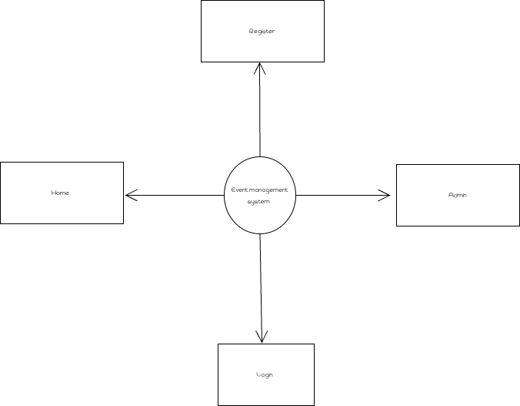

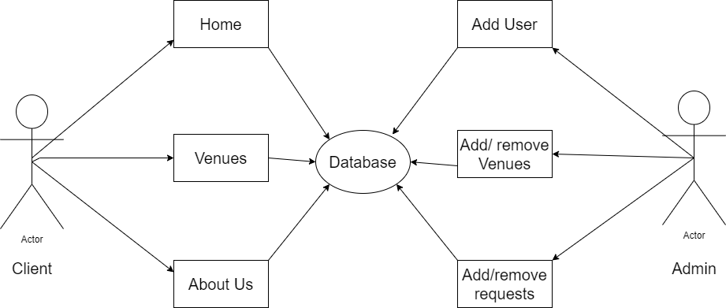

**5.2 Process Specification / Activity Flow Diagram:**

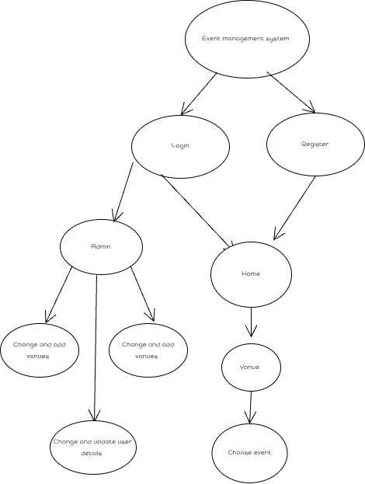

**5.3 Data Dictionary:**

|  |  |  |  |
| --- | --- | --- | --- |
| **Fields:** | **Data type:** | **Description:** | **Source table:** |
| id | Int | Unique identifier | .Users |
| name | String | Name of user | Users |
| username | String | Username of user | Users |
| password | String | User password | Users |
| type | Int | Two types admin or staff | Users |
| id | Int | Event id | Event |
| venue_id | Int | Unique identifier of venue | Event |
| event | String | Object of data | Event |
| description | String | About event | Event |
| schedule | String | Time of event | Event |
| type | Int | Types of events | Event |
| capacity | Int | Human capacity | Event |
| amount | Int | Entry fee | Event |
| id | Int | Venue id | Venue |
| venue | String | Venue details | Venue |
| address | String | Address of vanue | Venue |
| description | String | About place | Venue |
| rate | Int | Place rent | Venue |
| Id | Int | Booking id | Venue_booking |
| Name | String | Booker name | Venue_booking |
| Address | String | Booker address | Venue_booking |
| email | String | Booker email | Venue_booking |
| Contact | String | Booker contact | Venue_booking |
| Venue_id | Int | Venue id | Venue_booking |
| duration | String | Days and hours of event | Venue_booking |
| status | Int | 3 types verification,confirm, cancel | Venue_booking |

**5.4 Entity-Relationship Diagram / Class Diagram:**

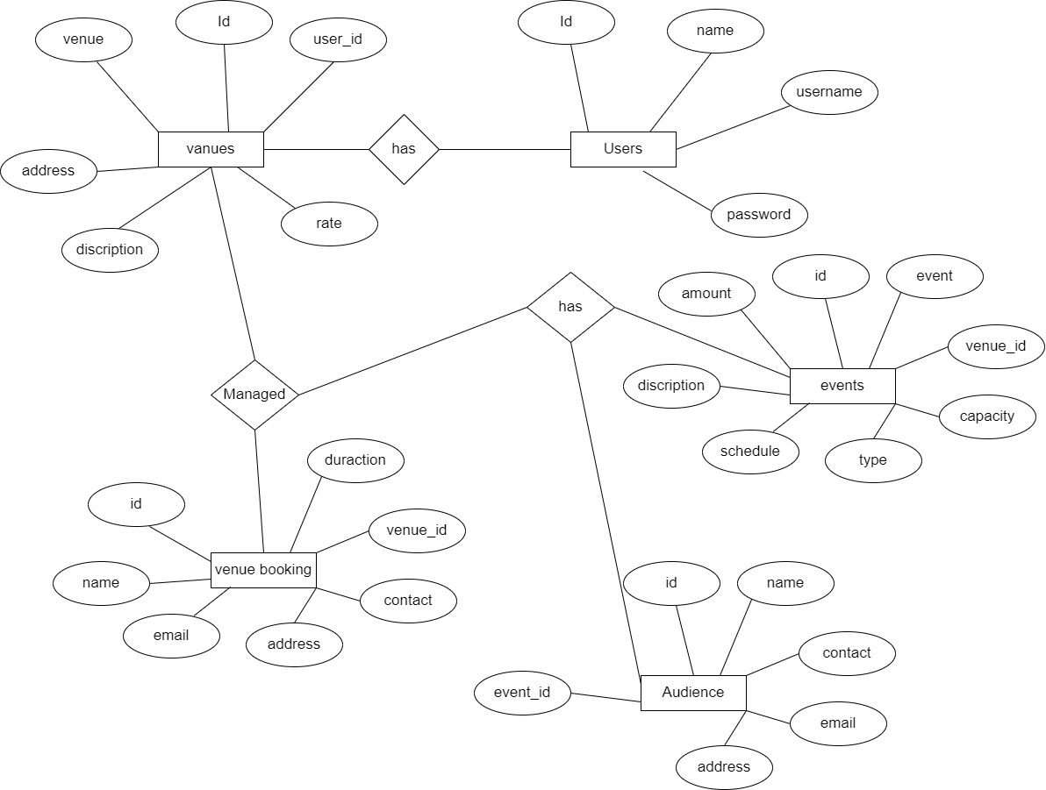

**6. System Design**

**6.1 Database Design:**

|  |  |
| --- | --- |
| Users | |
| id | |
| name | |
| Username | |
| password | |
| Type | |
| Venue |
| id |
| venue |
| address |
| discription |
| rate |
| user_id |
| Venue booking |
| id |
| name |
| email |
| address |
| contact |
| venue_id |
| duration |
| events |
| id |
| venue ID |
| event |
| description |
| schedule |
| type |
| capacity |
| amount |
| audience | |
| id | |
| name | |
| contact | |
| email | |
| address | |
| event_id | |

**6.2 Directory Structure:**

* + - **Frontend side:**

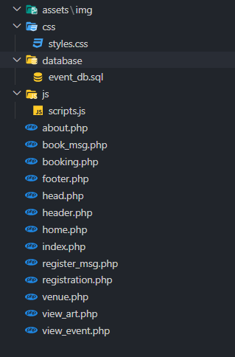

* + - **Server-side:**

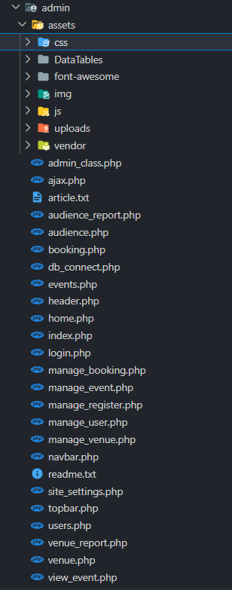

**6.3 Input Design:**

* + - **Admin Login page:**

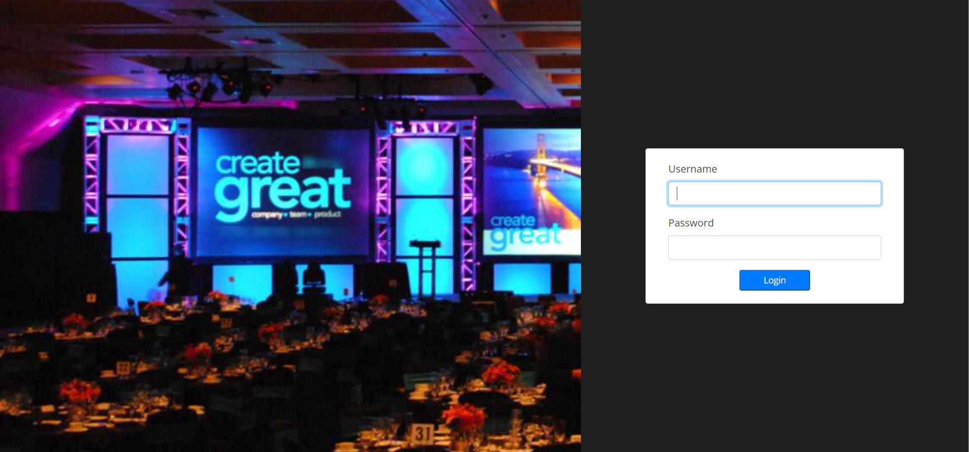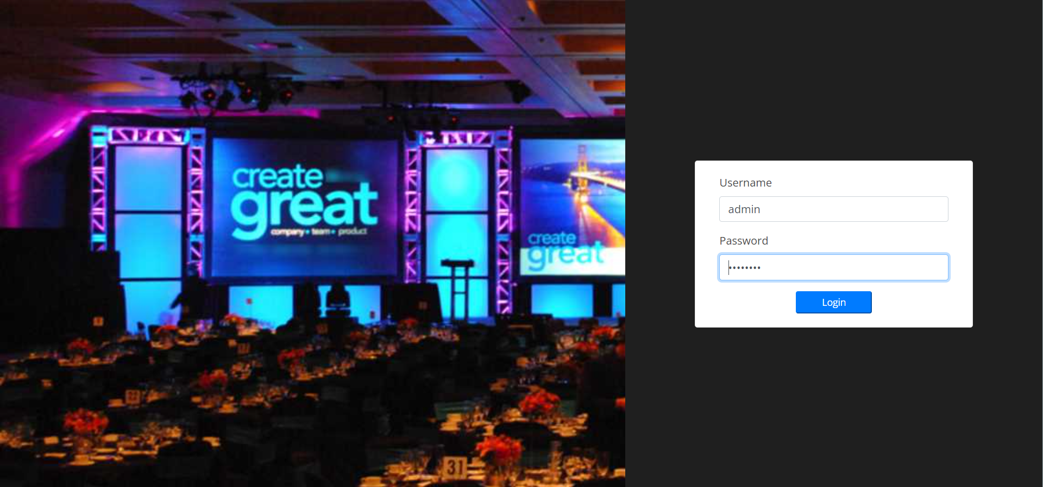

* **Admin Users page:**

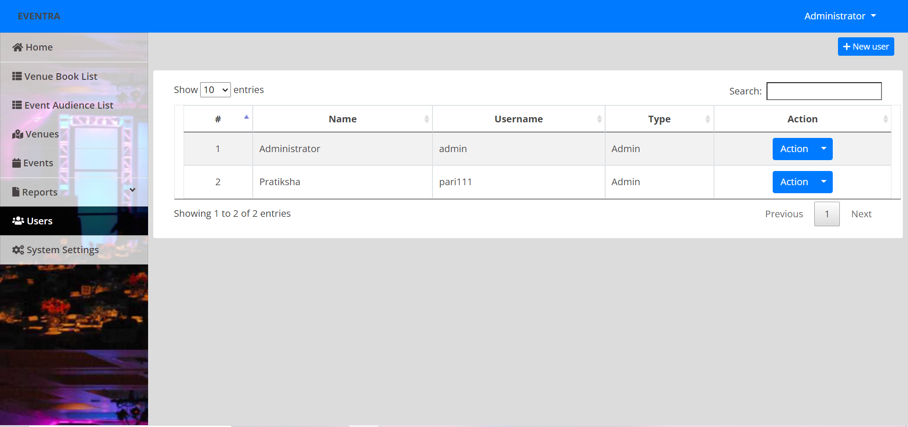

* **Admin venue page:**

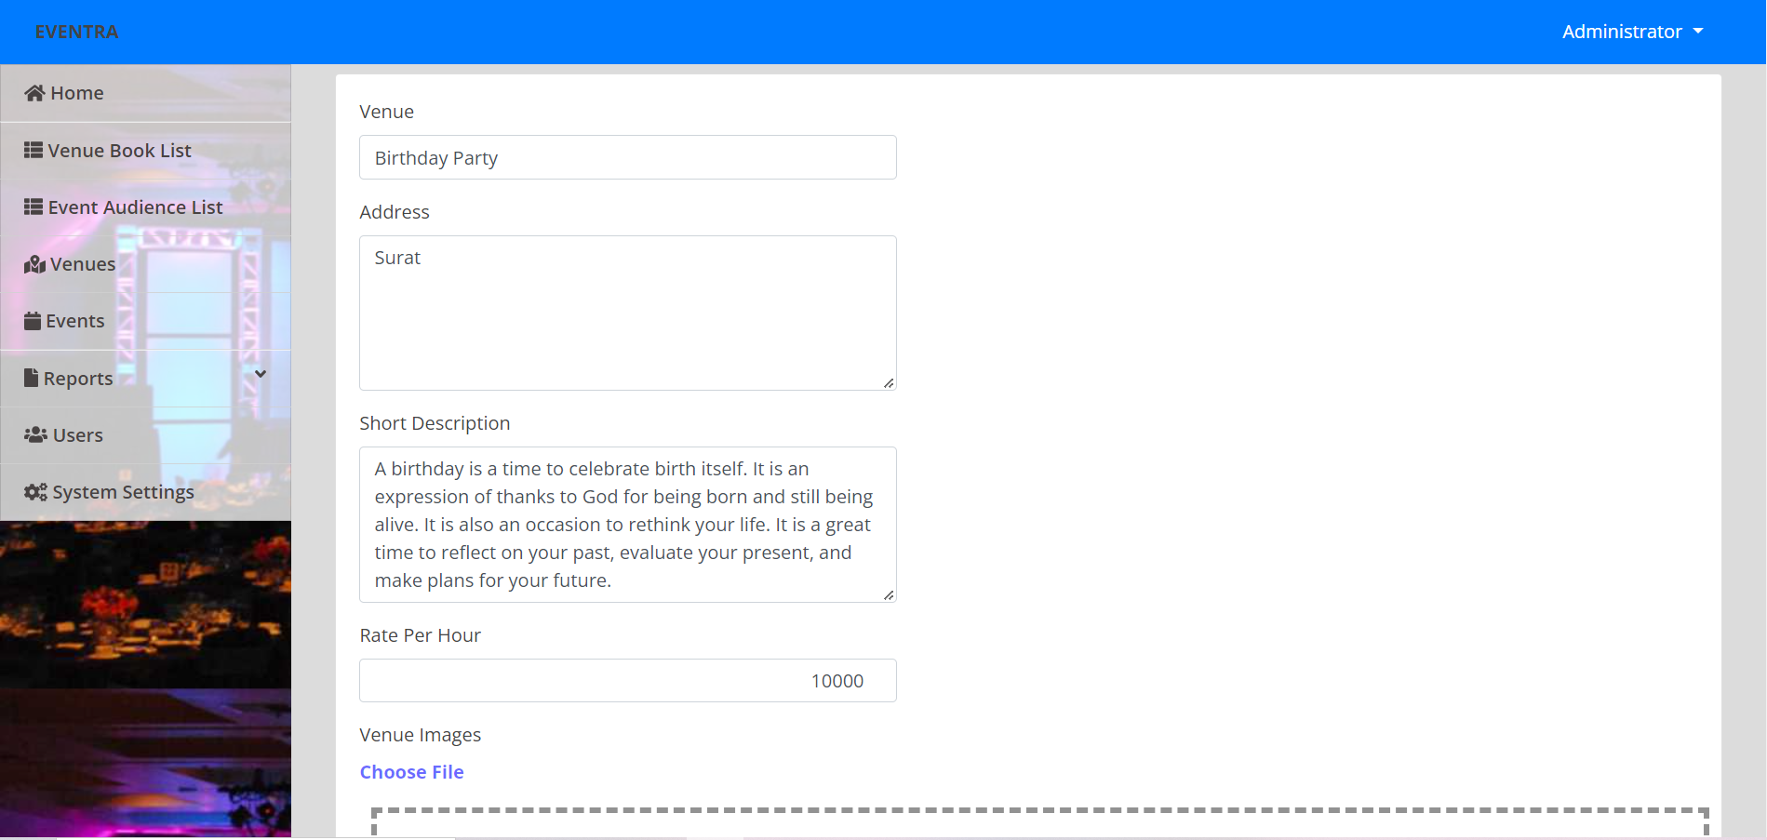

* **Venue Input data:**

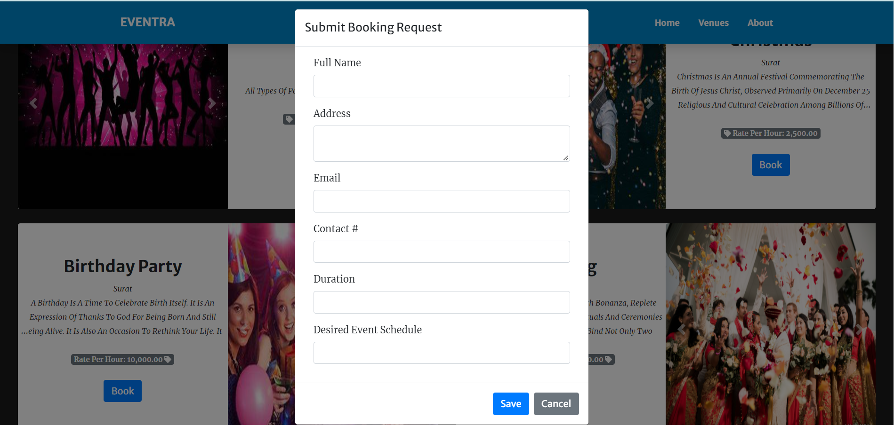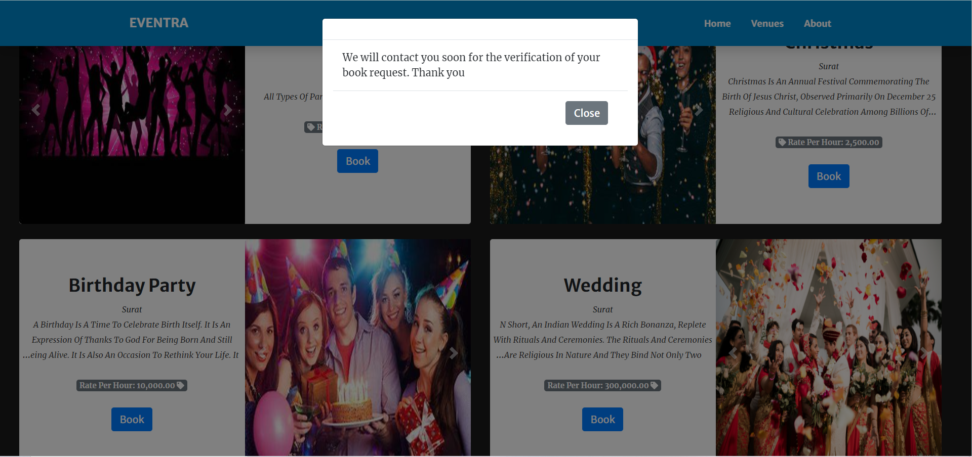

**6.3 Output Design:**

* + - **Home Page:**

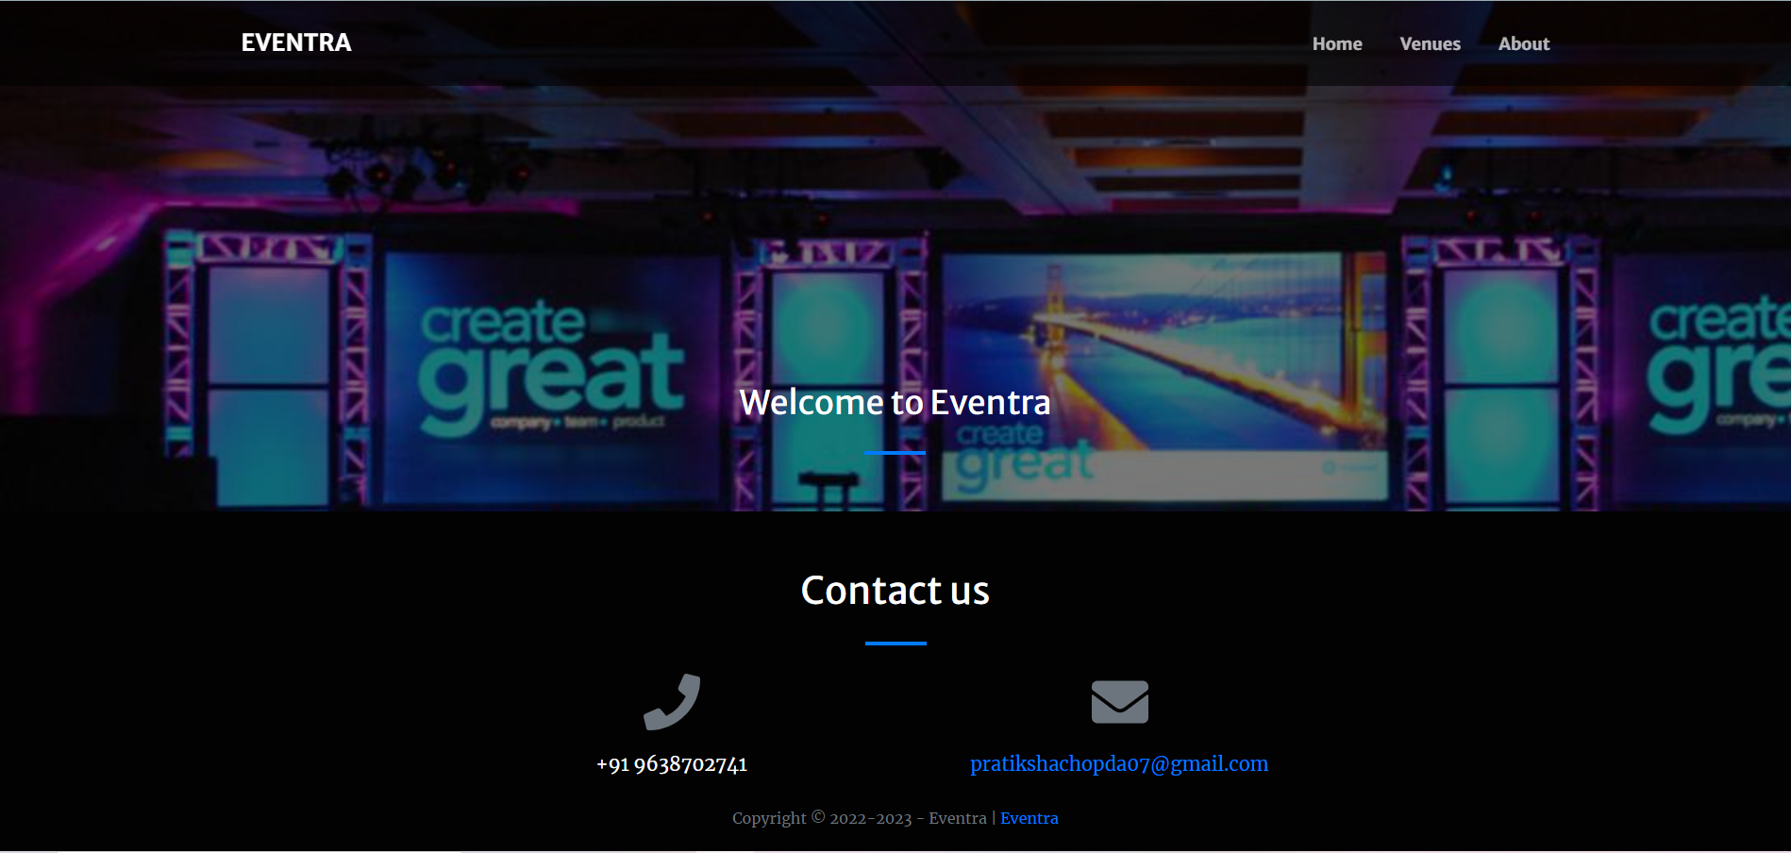

* **Venue Page:**

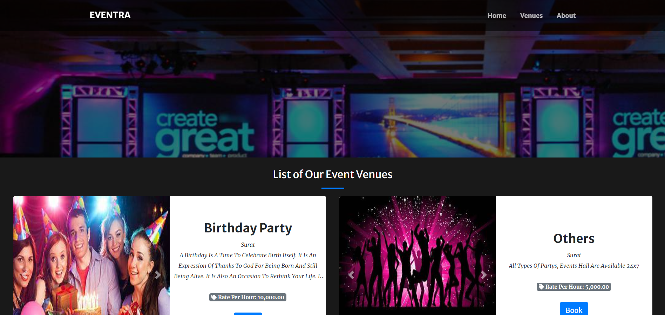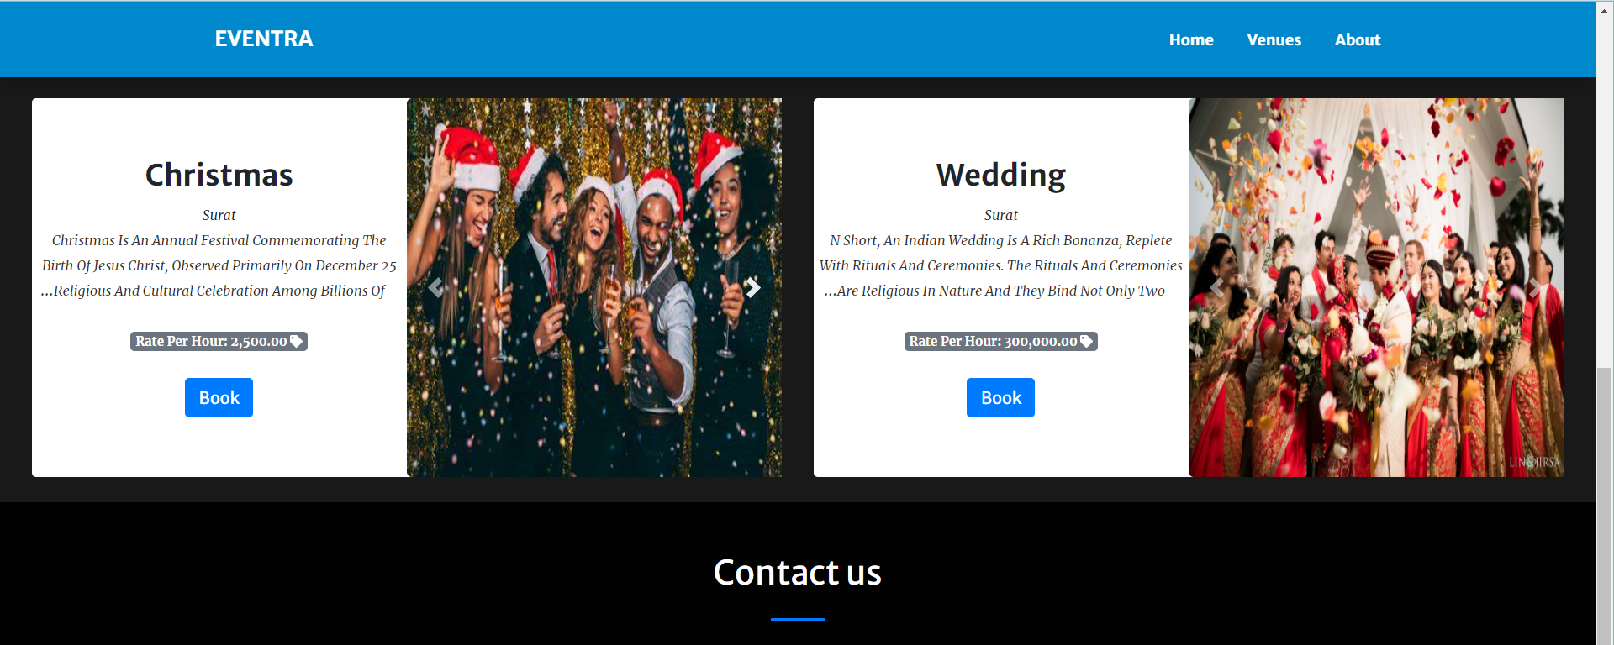

* **About page:**

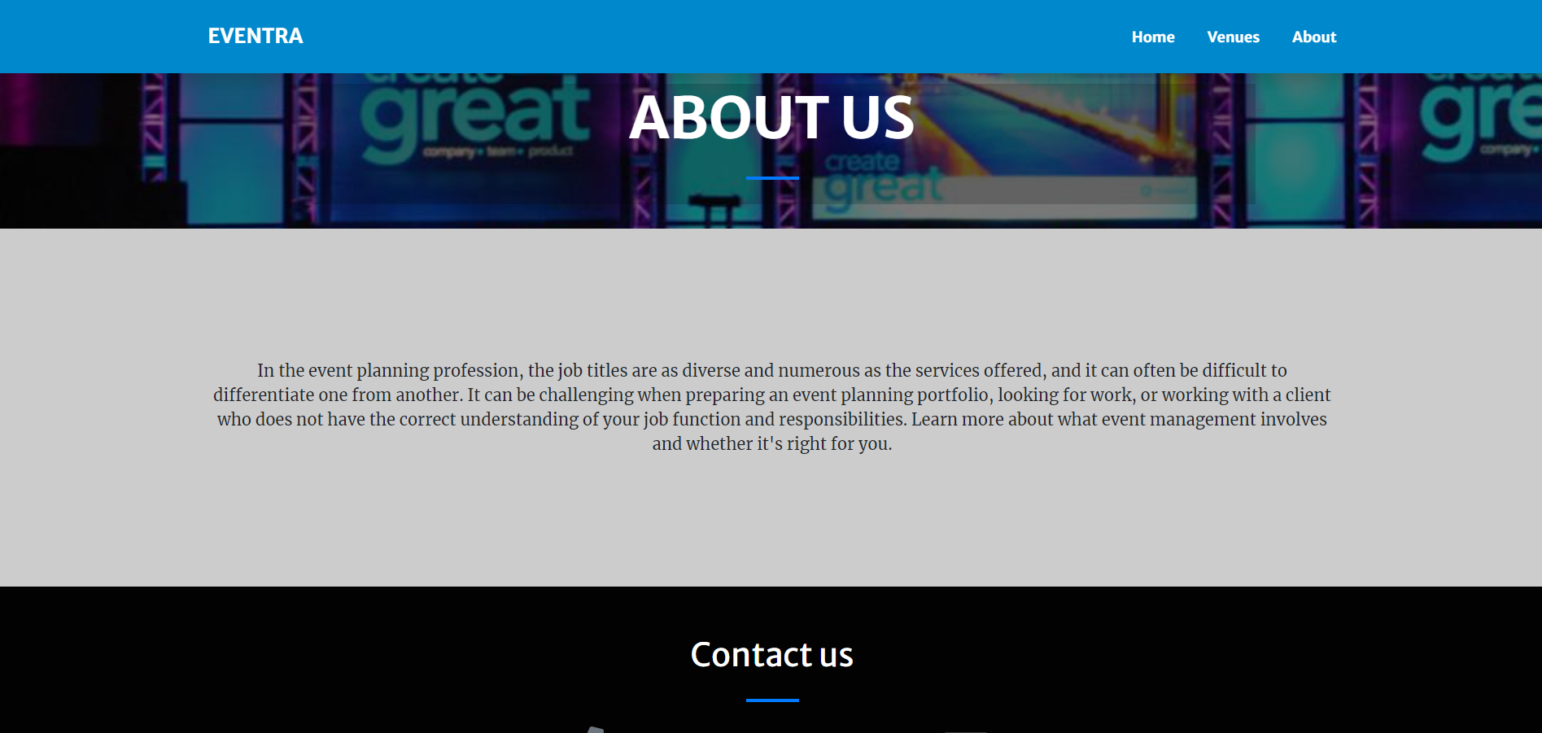

* **Admin panal:**

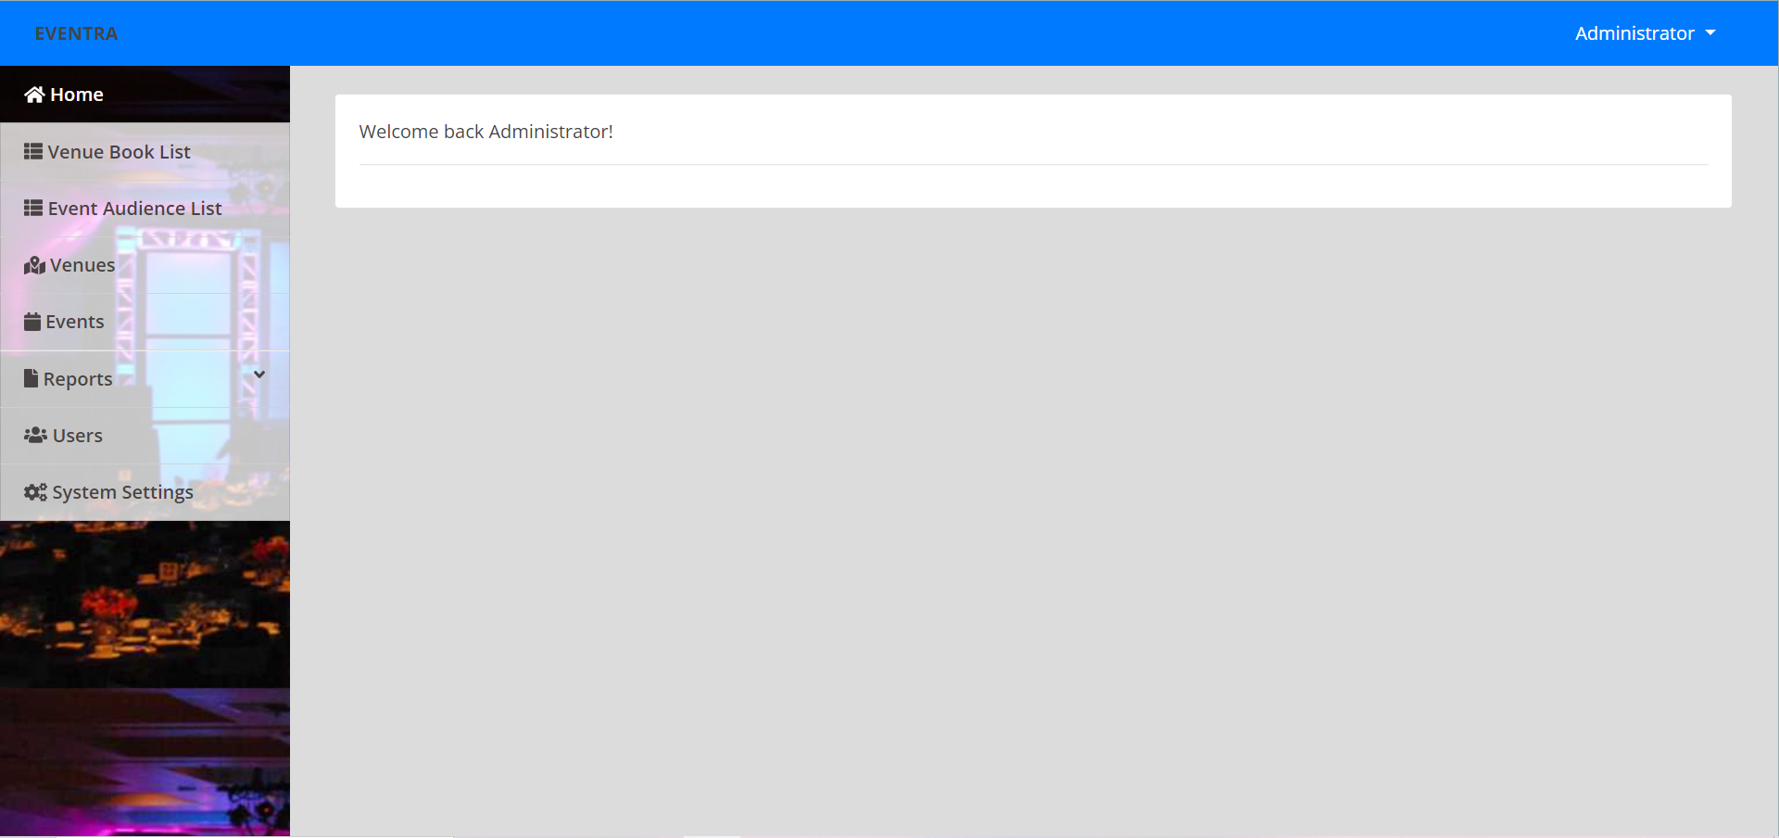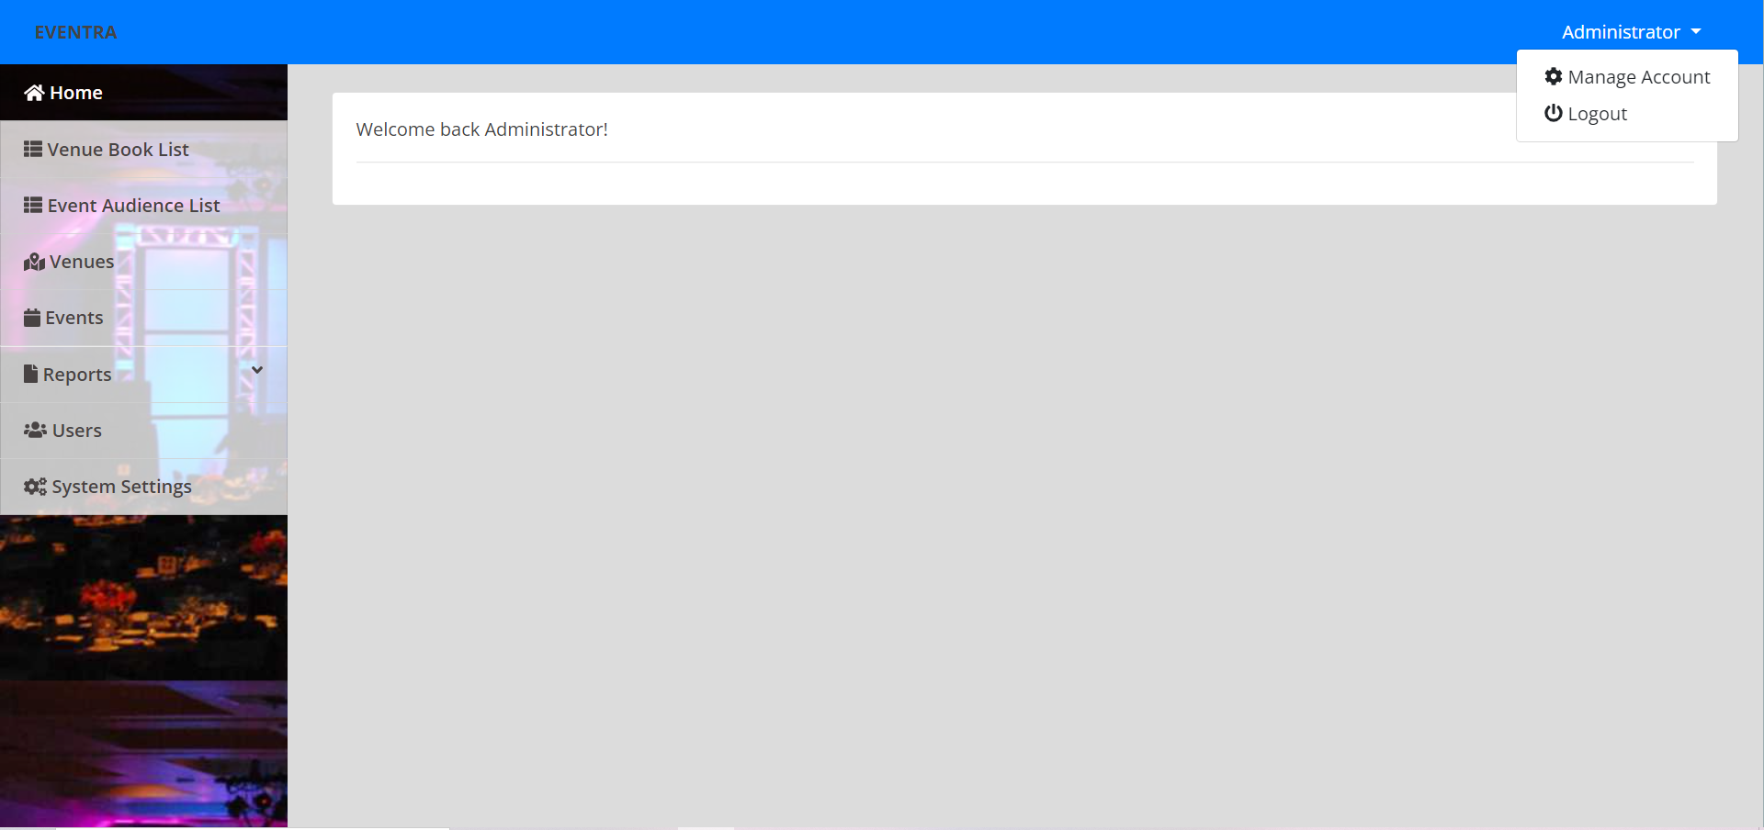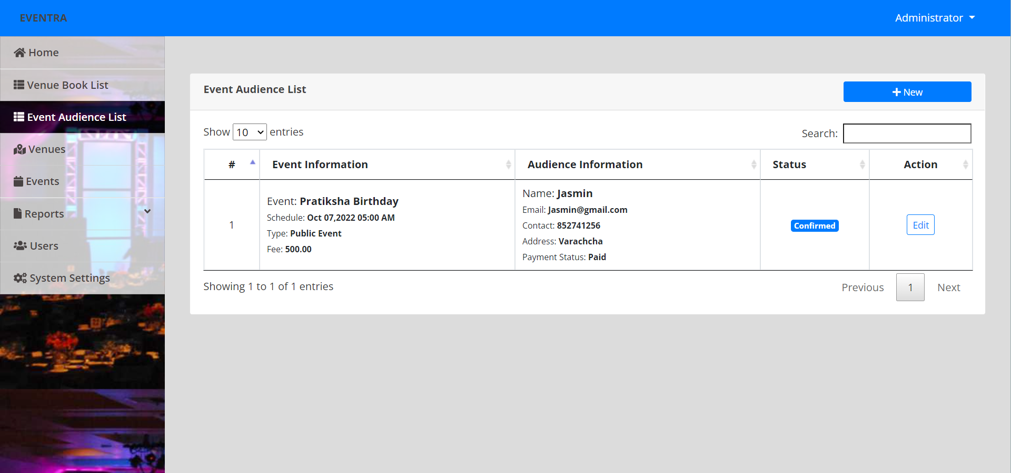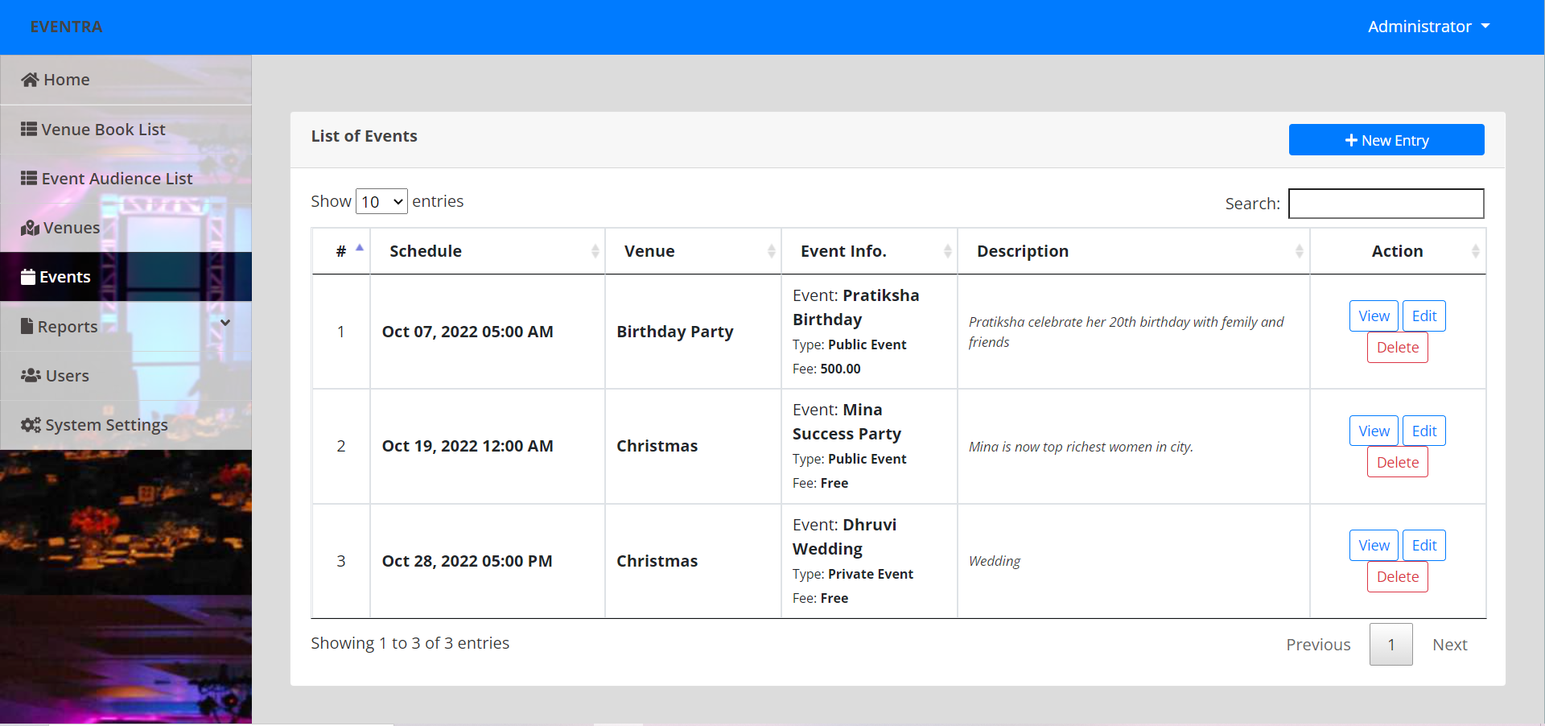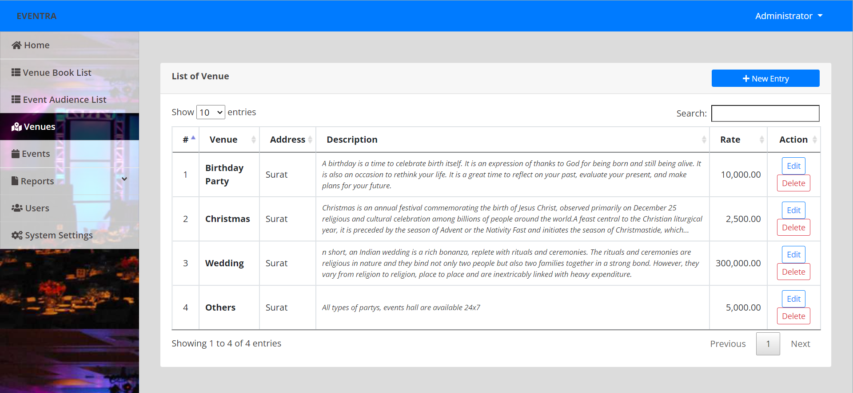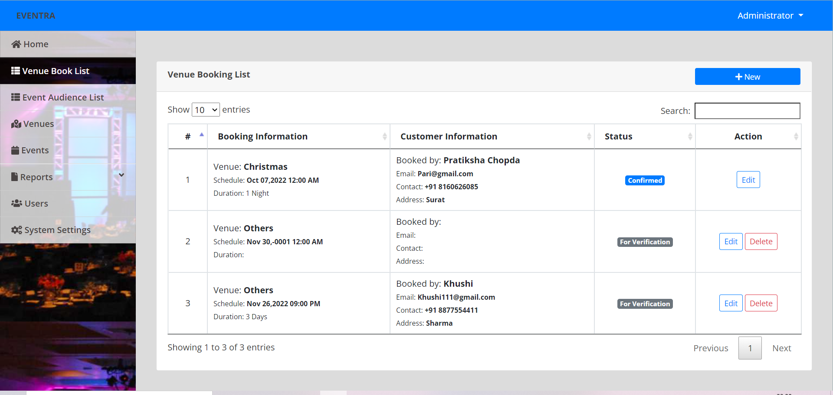

**7. Software Testing:**

**Software Testing is Important** because if there are any bugs or errors in the software, it can be identified early and can be solved before delivery of the software product. Properly tested software product ensures reliability, security and high performance which further results in time saving, cost effectiveness and customer satisfaction.

* + - **Integration Testing:**

In this type of process of testing the interface between two software units or modules. It focuses on determining the correctness of the interface. The purpose of integration testing is to expose faults in the interaction between integrated units. Once all the modules have been unit tested, integration testing is performed.

* + - **System Testing:**

System Testing includes testing of a fully integrated software system. Generally, a computer system is made with the integration of software (any software is only a single element of a Computer system). The software is developed in units and then interfaced with other software and hardware to create a complete computer system. In other words, a computer system consists of a group of software to perform the various tasks, but only software cannot perform the task; for that software must be interfaced with compatible hardware. System testing is a

Series of different type of tests with the purpose to exercise and examine the full working of an integrated software computer system against requirements.

**8. Limitations and Future Scope of Enhancements**

* + - **Limitations:**

There are mainly two limitations of project and that are:

* + - * The firewall is to be disabled for intra network.
      * It is dependent on the specific algorithm used.

* + - **Future Scope of Enhancements:**

There is always a room for improvements in any software package, however good and efficient it may be done. But the most important thing should be accept further modification. Right now we are just dealing with event management. In future this software may be extended to include features such as:

Event decoration

Out of city event management

Better offers

**9. References**

[Bootstrap · The most popular HTML, CSS, and JS library in the world. (getbootstrap.com)](https://getbootstrap.com/)

[PHP: Hypertext Preprocessor](https://www.php.net/)

[jQuery](https://jquery.com/)

[W3Schools Online Web Tutorials](https://www.w3schools.com/)